Email Blast for Tech Talk Time 2026 – Talk #1

Tech Talk Time 2026 – Talk #1
(Why Do We Need to Consider Ozone Application for Drinking Water Treatment - Case Study)
The Technical Programs Committee welcomes all Members (PEO and OACETT) to join them for this first presentation in their continued series of technical talks into 2026, provided by various speakers in numerous areas of science, technology and engineering. This talk will be focused on the use of ozone for treating drinking water, while providing specific case study examples for your understanding. Our guest speaker, Dr. Saad Y. Jasim, P.Eng., has several decades of leadership experiences in the environmental management and education, water treatment and quality, and water-reuse in the industrial and academic sectors, both nationally and internationally. Dr. Jasim has presented the topic of proper water treatment, extensively to many audiences around the world. His significant professional experiences include being the founding Chief Executive Office for the Walkerton Clean Water Centre, where he developed the Centre to be the premier provider of water-related technical training in Ontario. As well, he was the Director of Water Quality and Production at the Windsor Utilities Commission for numerous years, where he successfully implemented ozone as the primary disinfectant for the water treatment system, as the first in Ontario, while providing the City of Windsor residents the safe drinking water they presently enjoy. His talk will be based on his many experiences, in providing the public the safe drinking water they so deserve. The key details for the talk include the following points:

Date: Thursday, February 19, 2026
Time: 6:00 to 8:00pm
Location: St. Clair College (Main Building; Windsor Campus)
Room Number: A2204 in Alumni Hall (new Zekelman School Classrooms; see attached map below)
Cost = Free admission!!!
Speaker’s Name: Dr. Saad Y. Jasim, P.Eng.
Title: President at SJ Environmental Consultants (Windsor) Inc.
Topic: Ozone Application for Drinking Water Treatment – Case Study

All members, non-members, students, friends and family are welcome to attend. Please register before 12 noon on the date of the event, by using the Eventbrite link (https://www.eventbrite.ca/e/peo-windsor-essex-chapter-tech-talk-time-2026-talk-1-tickets-1982208659460?aff=oddtdtcreator).

NOTE: The classroom at St. Clair College has limited capacity. A waiting list will be initiated based on the registration numbers. After registering, if you find that your plans have changed and you can no longer attend, please contact us for cancelling your ticket. This will allow us to offer those on the waiting list a ticket to attend. Thanks for being considerate to others who might want to listen to this informative talk!

For any questions regarding the event, please feel free to contact Sean McCann, P.Eng. (spmccann13@hotmail.com or 519-890-7377).

St. Clair College (Main Building; Windsor Campus) Map
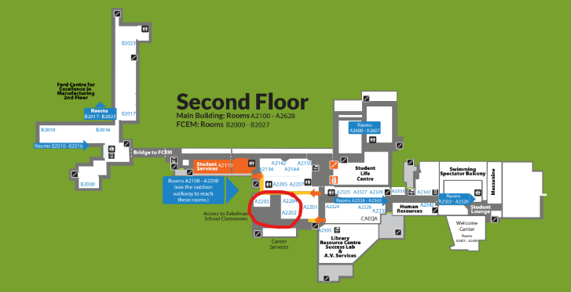
Presentation room is A2204 in Alumni Hall (new Zekelman School Classrooms; see red circle on attached map above)

