**Professional Development Report (PDR)**

|  |  |  |  |  |
| --- | --- | --- | --- | --- |
| **Personal Details** | | | | |
| **Name:** |  | | **PEO File Number:** |  | |
| **Practice Information** | | | | | |
| **Area of Practice:** | |  | | | |

**How to complete this form:**

Please provide details on professional development activities you have undertaken to maintain your knowledge of current engineering laws, codes and standards.

Acceptable CPD activities must have learning content that helps the licence holder reduce their professional practice risk here in Ontario: helps them maintain their competence to practise professional engineering; be directly relevant to their engineering practice area(s); and be sufficiently technical or regulatory in nature. All delivery methods of learning activities are considered valid provided the learning content meets the admissibility requirements.

Please see the attached Examples of Recognized Learning Activities.

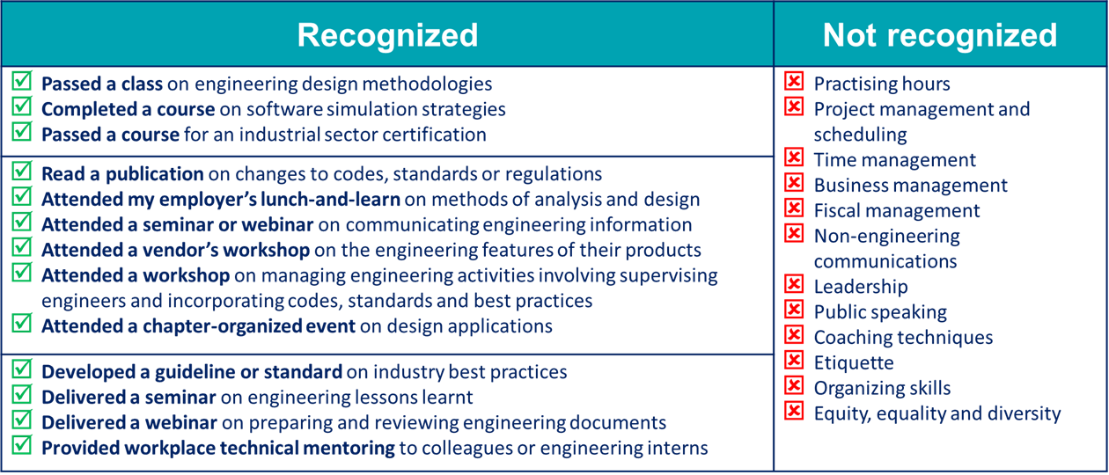

|  |  |  |
| --- | --- | --- |
| **Professional Development Report** | | |
| **Date** | **Activity** | **Hours** |
|  |  |  |
|  |  |  |
|  |  |  |
|  |  |  |
|  |  |  |
|  |  |  |
|  |  |  |
|  |  |  |
|  |  |  |
|  |  |  |
|  |  |  |
|  |  |  |
|  |  |  |
|  |  |  |
|  |  |  |
|  |  |  |
|  |  |  |
|  |  |  |
|  |  |  |
|  |  |  |
|  |  |  |
|  |  |  |
|  |  |  |
|  |  |  |
|  |  |  |
|  |  |  |
|  |  |  |
|  |  |  |
|  | **Total** |  |